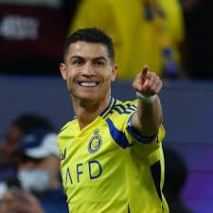
MMM

SPORTS GALA
  - 7
RONALDO

UET








WE ARE INVITED OUR WORTHLY TEACHER TO ATTEND SPORT GALA

20 NOV, 2025
7AM-2PM
JUNAID JAMSHED SPORTS GROUND

“TALENT WINS GAMES, BUT TEAMWORK AND INTELLIGENCE WIN CHAMPIONSHIPS.”

